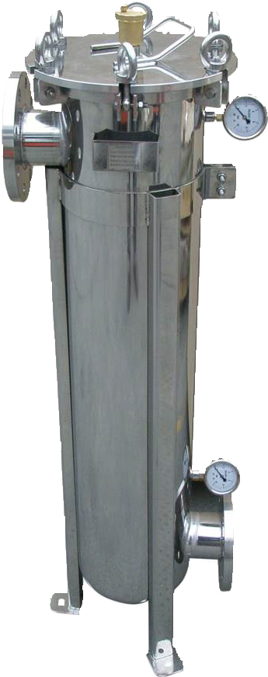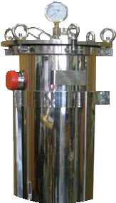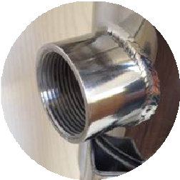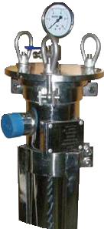

MAGNETIC BAG FILTER HOUSINGS



RANGE

DESCRIPTION

Stainless steel magnetic bag filter housing are devices for clarifying water in closed circuits for hot water in heating systems and also cooling and ice water circuits.

As far as the water is flowing through the filter, it will take corrosion and clogging of the circuits caused by the presence of metallic particles related to the phenomena of electrolytic currents in the water, the introduction of dissolved gases due to leakage losses or through the porosity of the pipes.

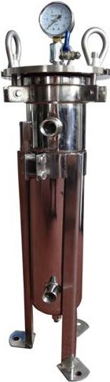
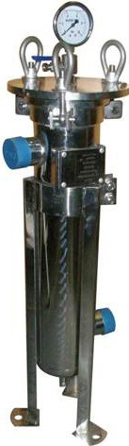
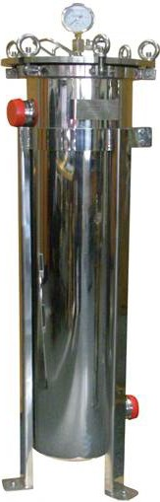
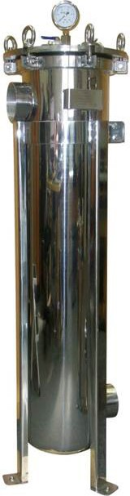
These phenomenas in the water will generate sediments and sludge, and, consequently, will slow down the circulation of the fluid; at same time, the system will loose energy, efficiency and the life duration of the pumps will be reduced and the exchangers will be clogged. Magnetic bag filter housing are an effective response to these problems.
B
C

D

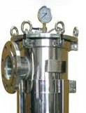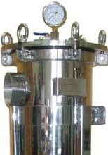A

Model | DN 20 | DN 32 | DN 40 | DN 50 | DN 80 | DN 80 B
Flow Rate  m³/h | 5 | 5 | 20 | 40 | 50 | 50
Pressure drop  bar | 0.15 | 0.15 | 0.21 | 0.25 | 0.21 | 0.21
Diameter  mm | 202 | 202 | 312 | 312 | 312 | 380
Diameter Lid  mm | 202 | 202 | 312 | 312 | 312 | 312
Dimensions | A min: 730 mm B: 355 mm  C min: 190 mm C max: 440 mm D: 114 mm | A min: 730 mm B: 355 mm  C min: 190 mm C max: 420 mm D: 114 mm | A min: 830 mm B: 480 mm  C min: 165 mm C max: 495 mm D: 219 mm | A min: 1120 mm B: 800 mm  C min: 165 mm C max: 485 mm D: 219 mm | A min: 1120 mm B: 800 mm  C min: 165 mm C max: 825 mm D: 219 mm | A min: 1120 mm B: 800 mm  C min: 188 mm C max: 858 mm D: 219 mm
Depending on the height position of the adjustable belt, the dimension “C” is variable.

TECHNICAL CHARACTERISTICS

TECHNICAL CHARACTERISTICS
Every kind of particles with a size greater than 50 microns will be stopped by the filter bag while the high magnetic field magnetic bars will capture all the ferrous particles resulting from the corrosion of the circuit.
In addition, the bag filter housing will allow the introduction of conditioning products such as corrosion inhibitors or antiscalant.

Filtration thickness: 50 microns are stopped by the filter bag
Polished 304 stainless steel treatment chamber with stainless steel magnetic bars for magnetic metal oxide capture. DN 20 and DN 32 model: 1 bar 300 mm
DN 40 model: 2 bars 300 mm
DN 50 model: 2 bars 600 mm
DN 80 and DN 80 Flange models: 2 bars 600 mm
Decantation by reduction of the speed of the water flow in the stainless steel chamber. EPDM O’ring sealing D. 124 mm torus D.6 mm.
Inlet and outlet, manometers pipes and bottom drain: all in Stainless steel Inlet and outlet on same side for BFH01Q model (unilateral)
Adjustable stainless steel feet
Closing of the cover by M12 wing bolts stainless steel with ball joints and clips, fully dismountable. Stainless steel basket and basket holder for holding the filter bag.
0-10 bars Glycerin Pressure gauge with brass pipe and air vent valve with D.4-6 mm cannula and compression. Connection ¼” male radial.
Delivered with T adaptor, ball valve purge and air bleed/filling valve or corrosion inhibitor /scaling for PE pipe 4-6 mm. Max. pressure: 10 bar
Max. temperature:90°C Drain with plug: ½” F 15x21 Fitting event ¼” F8/13
Recommended water quality: 14°dH Class 3 (or 25°F).

CHOICE OF THE MODEL FOLLOWING THE CIRCUIT TO BE TREATED IN DERIVATION
- DN20 model: A bypass circuit with 8 m³ flow (5 to 20 rooms - 2m³)
- DN32 model: A bypass circuit with 26 m³ flow (5 to 50 rooms - 8m³)
- DN40 Model: A bypass circuit with 52 m³ flow (50 to 200 rooms - 17m³)
- DN50 Model: A bypass circuit with 103 m³ flow (200 to 400 rooms - 34m³)
- DN80 Model: A bypass circuit with 180 m³ flow (400 to 600 rooms - 48m³)

THE MUST THAT MAKE THE DIFFERENCE IN QUALITY
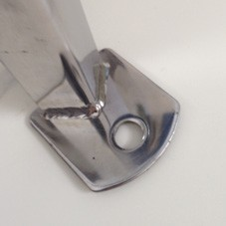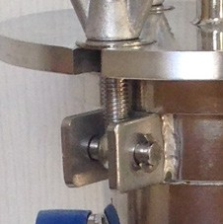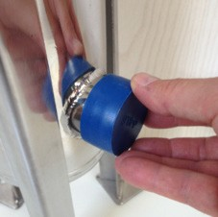
Ground fixing Demontable axes Fittings

DIAGRAM


Outlet
1
10
Automatic drain
Balancing valve
2
Stop valve
7
Event valve
Mano 10
bars
8
3
Circulator
4
Filling shut-off valve
6
Stop valve
5
Drain valve
circulator
Preparation unit with circulator

9
With balancing valve on primary and/or circulator (not supplied)

SET UP
Magnetic Bag Filter Housing is set up in derivation on the return of the circuit to be treated. Mounting a balancing valve or a charge pump will force the flow of the fluid in the filter
The inlet and outlet isolation valves will also allow to use the filter as a pot for introducing products for the punctual treatments of the circuit.
Draining a low point to facilitate loading of the filter bag and cleaning of the magnetic bars.

IDEAL INSTALLATION
- The filtration station is placed and fixed on the ground by its 3 feet
- The filtration station is placed close to the preparation unit (9) (boiler,..),on the loop return circuit and at a suitable height in order to enable its connection to the unit of preparation and, on the other hand, its emptying by the drain present on its lower wall (shut off valve (5) and drainage of this drainage water.)
- A shut-off valve will be mounted upstream (2) and downstream (6) of the filtration station to allow for maintenance without interrupting the operation of the plant.
- A water inlet will be provided for filling with a shut-off valve (4).
- An event ball valve (7) and a 10 bar pressure gauge (8) will be mounted on the cover with a 2 way connection.
- A balancing valve (1) and a circulator (3) will be mounted in the loop return circuit.

MAINTENANCE

Once a year*, clean the collector by changing the filter bag or cleaning it by turning it up and cleaning the magnetic bars with a dry rag.

DISMANTLING
- Close the inlet and outlet valve.
- Depressurize by opening the drain valve at the bottom.
- Open event on top.
- Loosen the wing bolts to pivot the lid.
- Take out the spring and the magnetic system and clean with a rag.
- Remove the filter bag from the stainless steel basket, clean it and/or replace it with a new one.

REASSEMBLY
- Repositionning the filter bag in the stainless steel basket as well as the bars. 8.Close the filter cover.
- Close the drain valve.
- Open the inlet valve until overflow by the event. 11.Close the event.
12.Open the outlet valve.

*For the technical reasons, the sludge collecting filters must be drained regularly according to the state and quantity of water in the circuit, at least once a year. At the time of this maintenance, clean the magnetic bars as well as the stainless steel sieve basket and change the filter bag.

QUALITY OF STAINLESS STEEL, WELDING AND PERFECT FINISHING

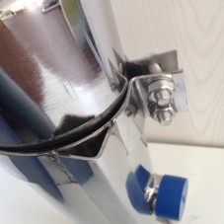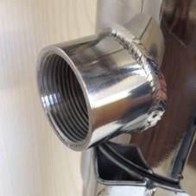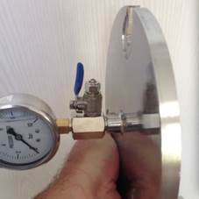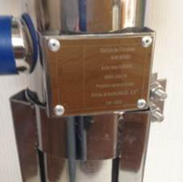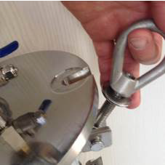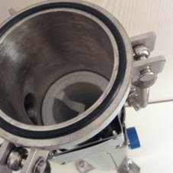

Tolery and walls: stainless steel 6 mm
Fittings and walls: stainless steel 6 mm
Cover: Stainless steel 10 mm
Laser engraved plate
M12 stainless steel wing bolts
O’ring and throat

QUALITY ALL OPTIONS

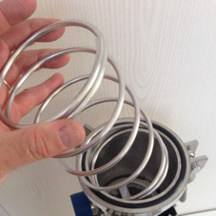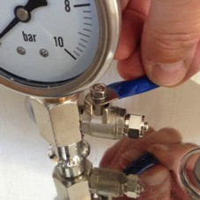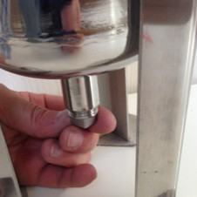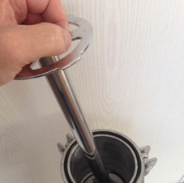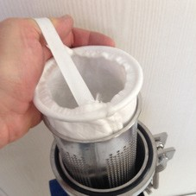

Adjustable in height
Stainless steel spring
Air purge tap 4-6 mm
Drain plug 1/2”
Stainless steel magnitic bars
Stainless steel basket and bag PP

DIMENSION YOUR FILTER

Number of rooms | Power boiler (kw) | Volume of the system (m³) | Flow (m³/h) | Treated flow (m³/h) | Type
5 - 20 | 190 | 2 | 8 | 2 | DN 20
5 - 50 | 300 | 4 | 13 | 3 | DN 32
450 |  | 6 | 19 | 5
600 |  | 8 | 26 | 6
50 - 200 | 750 | 10 | 32 | 8 | DN 40
900 |  | 13 | 39 | 10
1050 |  | 15 | 45 | 11
1200 |  | 17 | 52 | 13
200 - 400 | 1350 | 19 | 58 | 15 | DN 50
1500 |  | 21 | 65 | 17
1650 |  | 23 | 71 | 18
1800 |  | 25 | 78 | 20
1950 |  | 27 | 84 | 21
2100 |  | 30 | 91 | 23
2250 |  | 32 | 97 | 24
2400 |  | 34 | 103 | 26
400 - 600 | 2550 | 36 | 110 | 28 | DN 80
2700 |  | 38 | 117 | 30
2850 |  | 40 | 124 | 32
3300 |  | 42 | 132 | 34
3450 |  | 44 | 139 | 36
3700 |  | 46 | 146 | 38
3850 |  | 48 | 153 | 40

THERMAL INSULATION JACKET
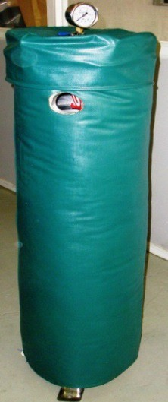
Classification M1 and M0 in heating and air conditioning systems

Completely protects the filtration unit from heat losses in heating installations, condensation in ice water installations. This jacket is mounted very easily without tools, after connection to the installation, around the body and on the cover and thus isolates the whole of its environment.
Advantages: facilitates and simplifies maintenance within the filtration unit by removing the removable insulated cap.
Cleanliness site: condensation removed: more water runoff
Saving energy: more energy losses around the filter.

APPLICATION

Commercial
Buildings, hotels, restaurants, schools, home for elderly

Industry

